**TEST CASES**

**MAIN MENU**

**IT_CASE 1 :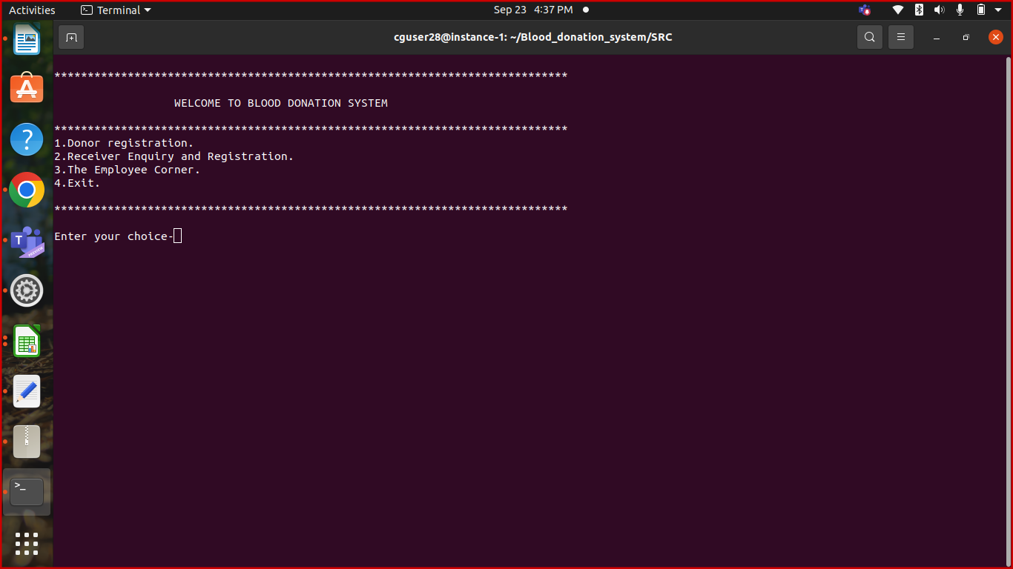 DONOR_REGISTRATION**

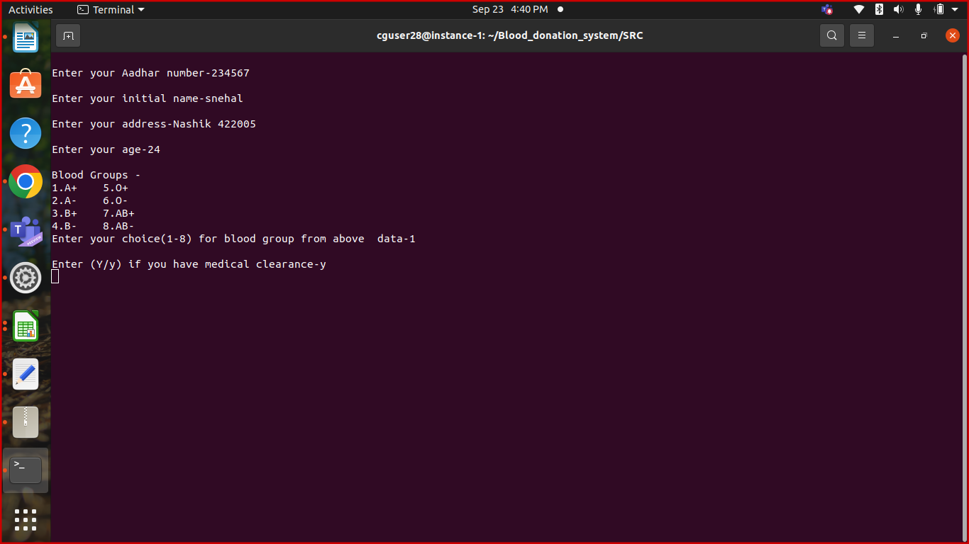

**IT_CASE 2 : DONOR_VALIDATION**

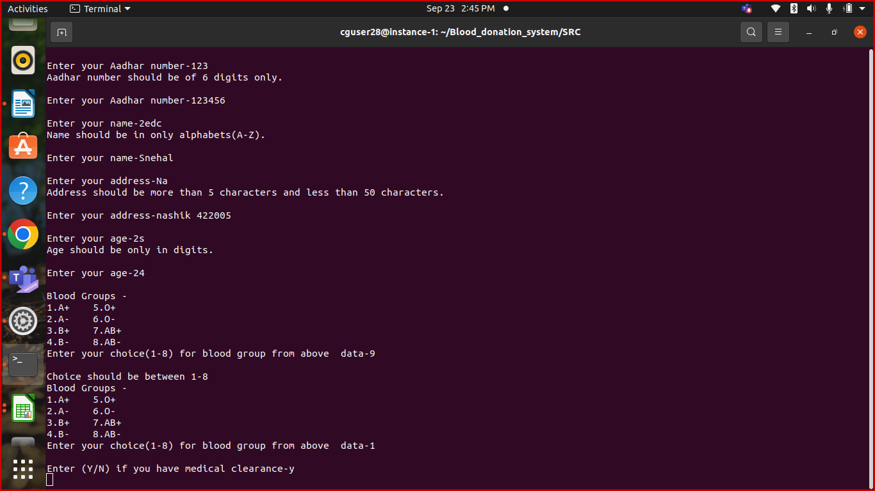

**IT_CASE 3 : RECEIVER_REGISTRATION**

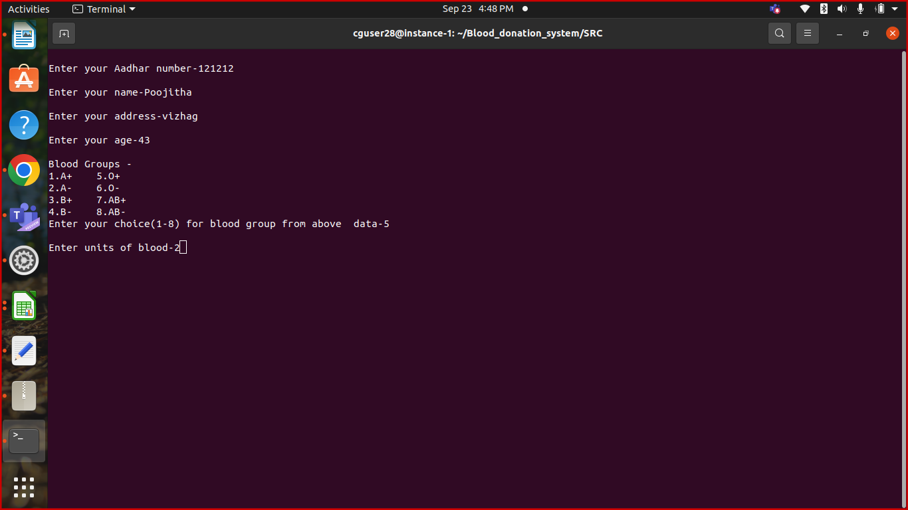

**LIST OF DONOR**

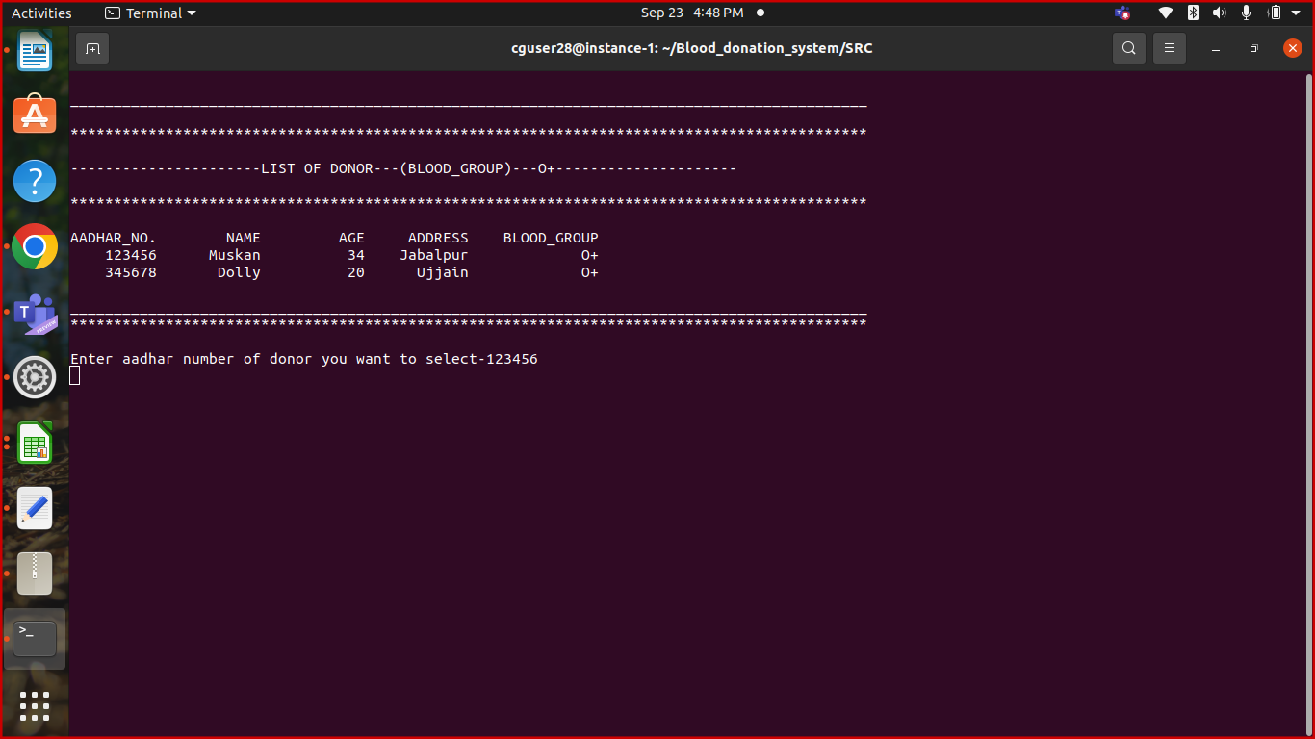

**IT_CASE 4 : EMPLOYEE_CORNER**

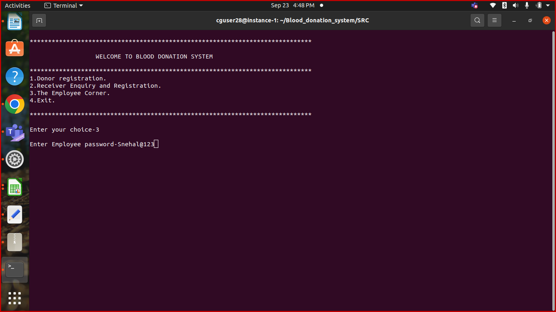

**IT_CASE 5 : SUBMENU (EMPLOYEE CORNER)**

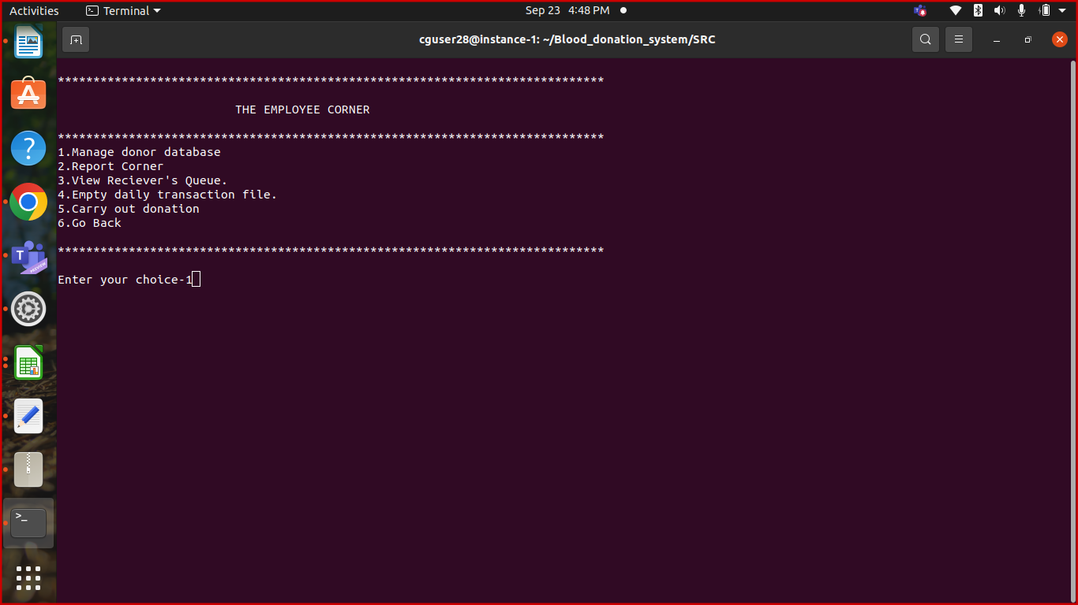

**MANAGE_DONOR_DATABASE**

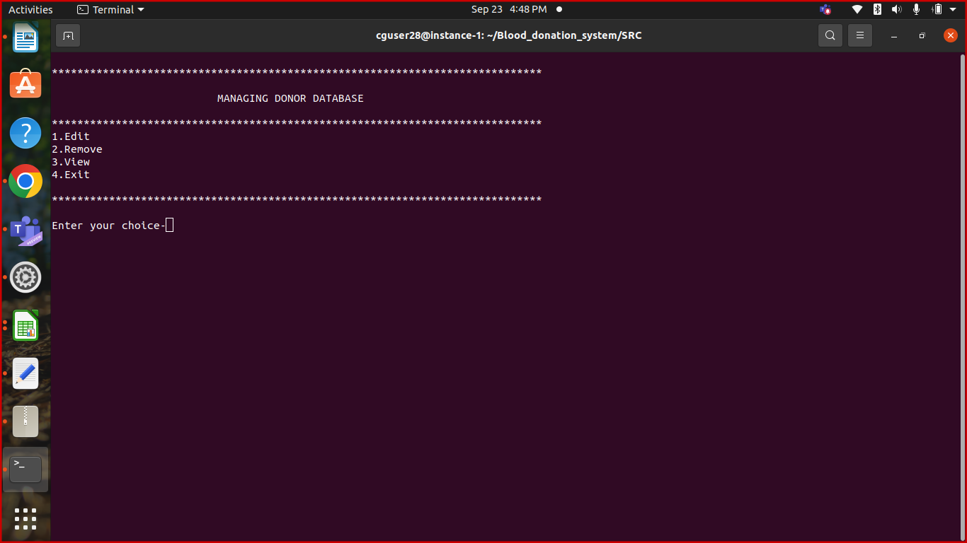

**IT_CASE 6 : EDIT_DONOR_DATA**

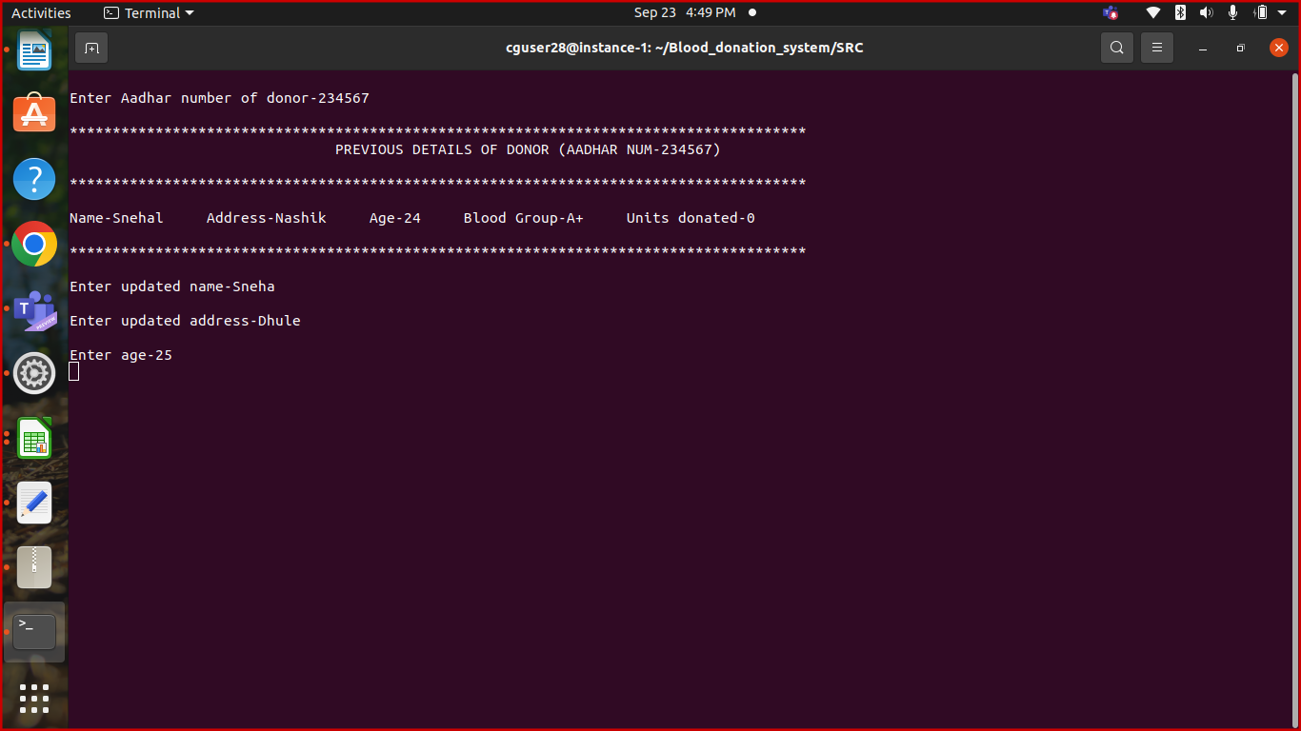

**IT_CASE 7 : REMOVE_DONOR_DATA**

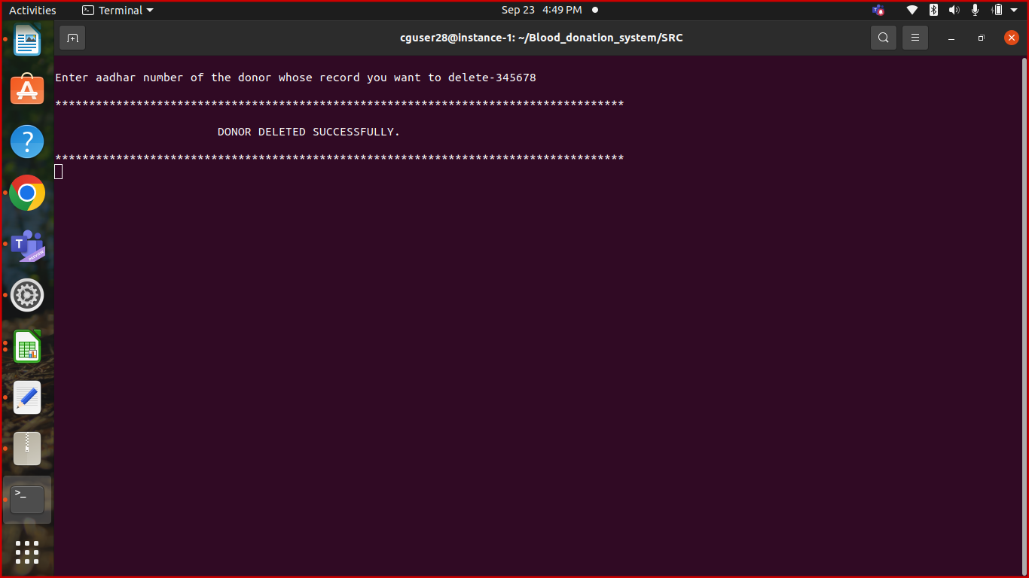

**VIEW DONOR DATA MENU**

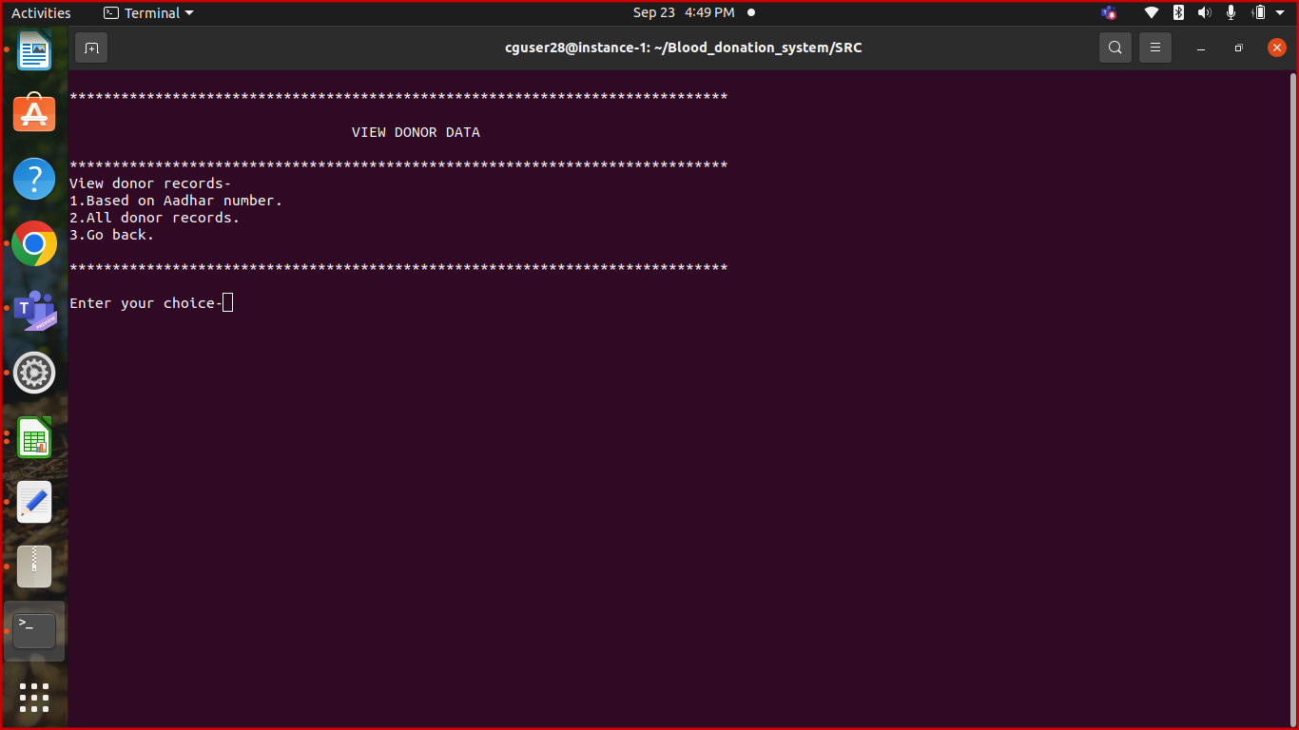

**IT_CASE 8 : VIEW_DONOR_DATA**

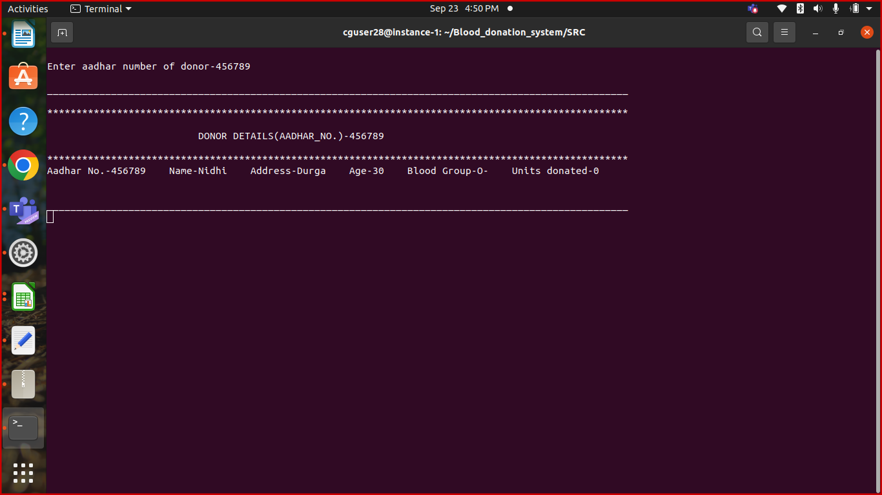

**IT_CASE 9 : VIEW_ALL_DONOR_DATA**

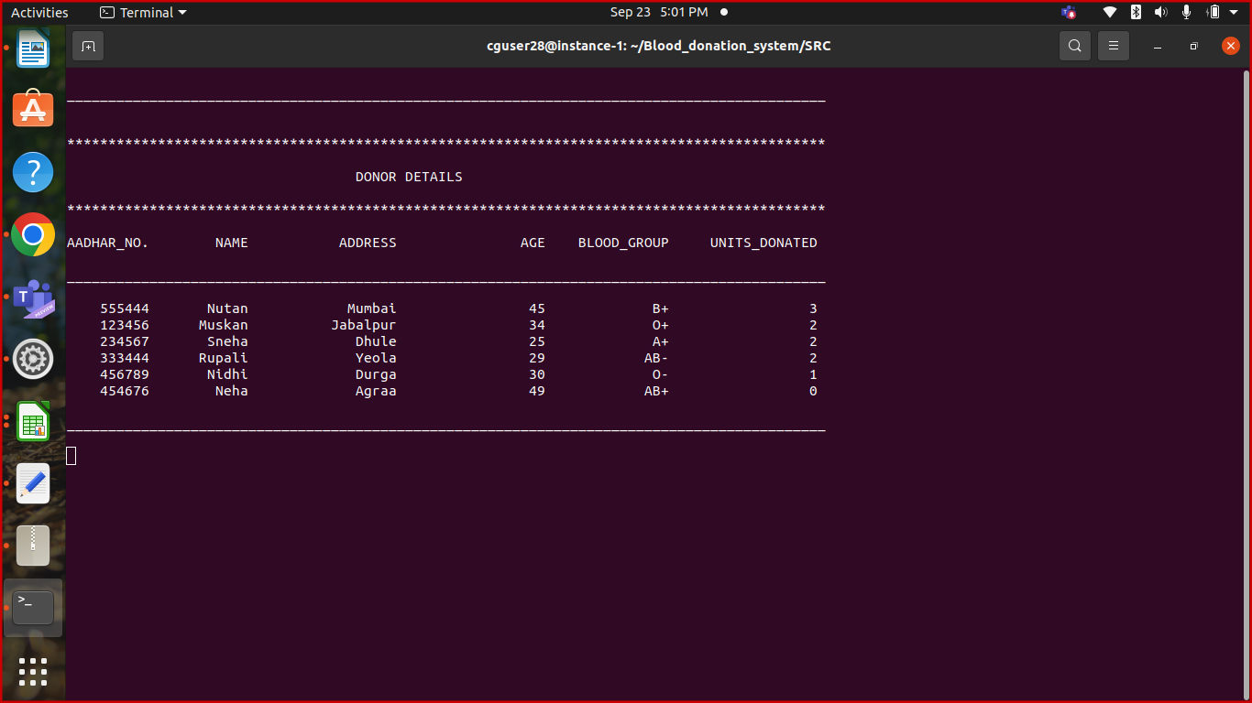

**IT_CASE 10 : VIEW_RECEIVER_QUEUE**

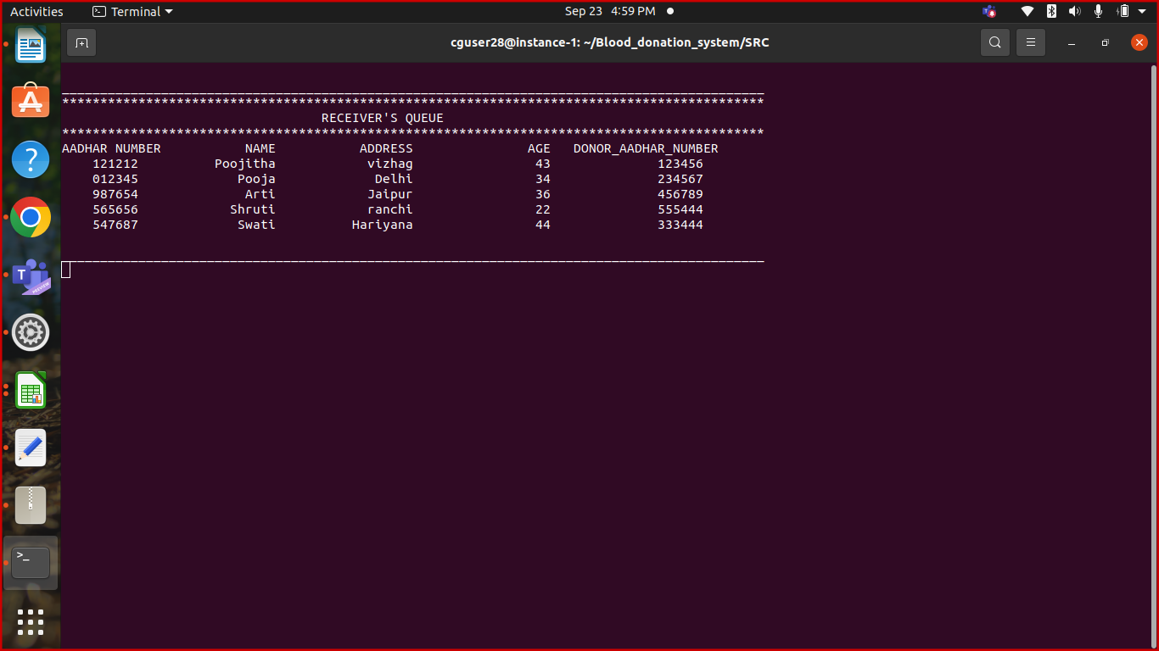

**IT_CASE 11 : CARRY_OUT_DONATION**

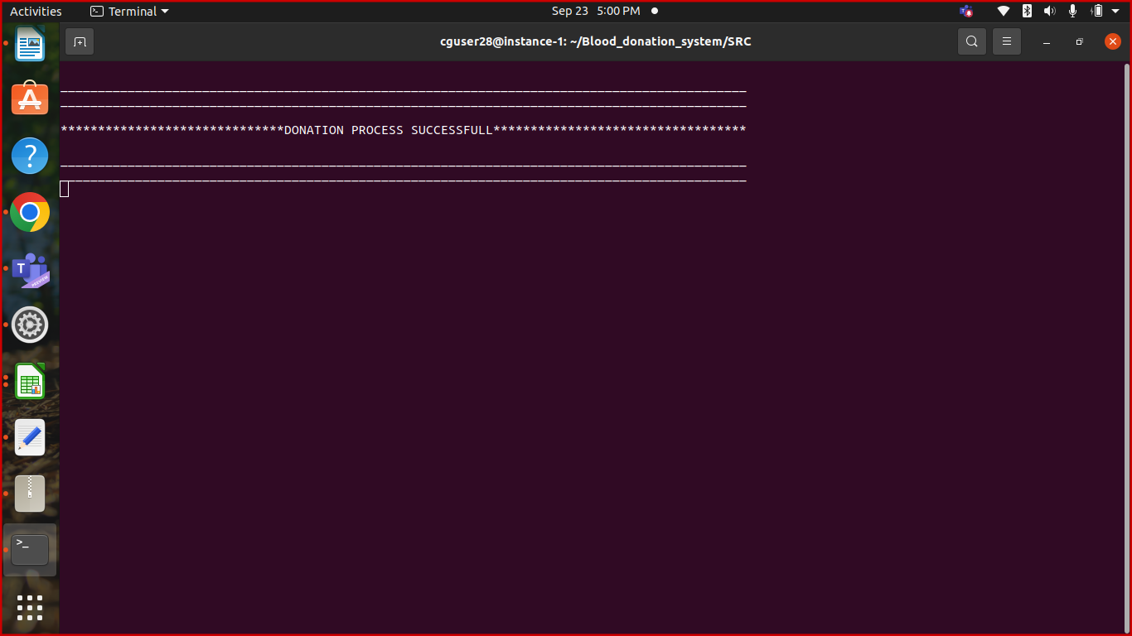

**IT_CASE 12 : DAILY_DONATION_REPORT**

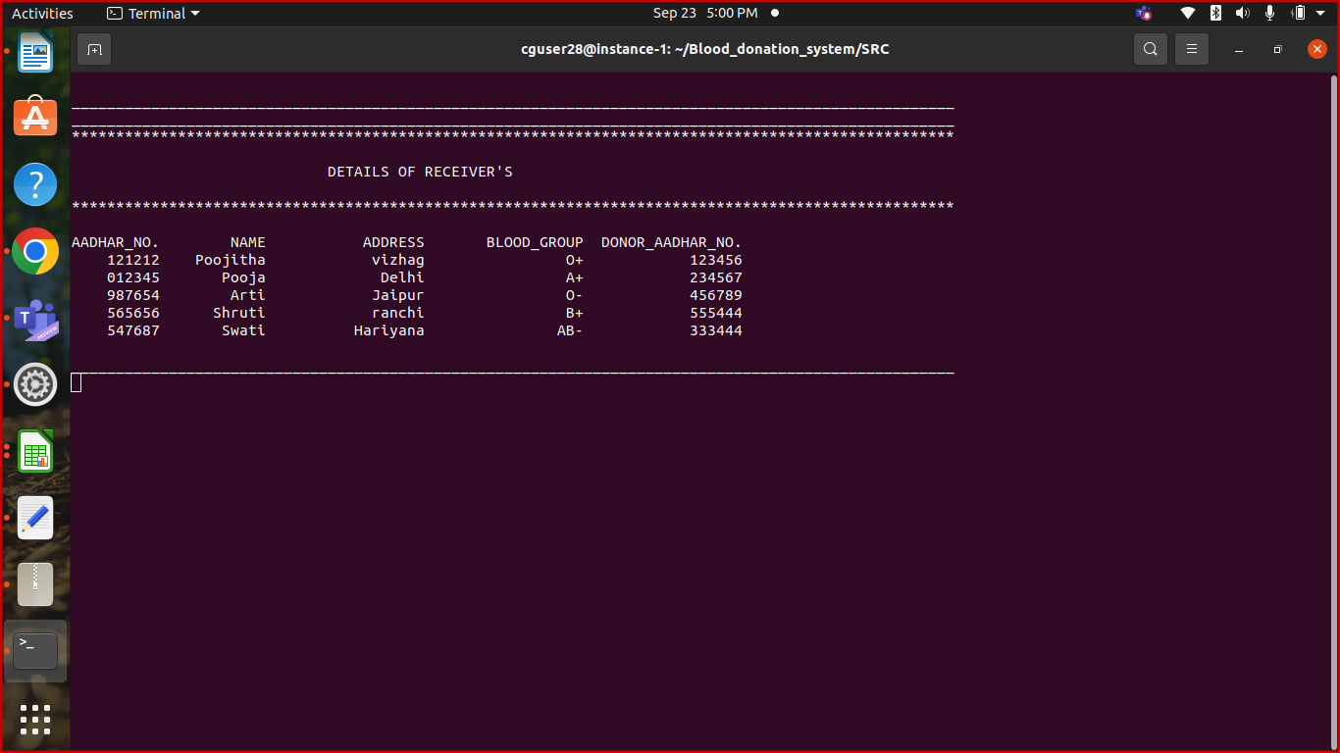

**IT_CASE 13 : FIVE_HIGHEST_DONOR_REPORT**

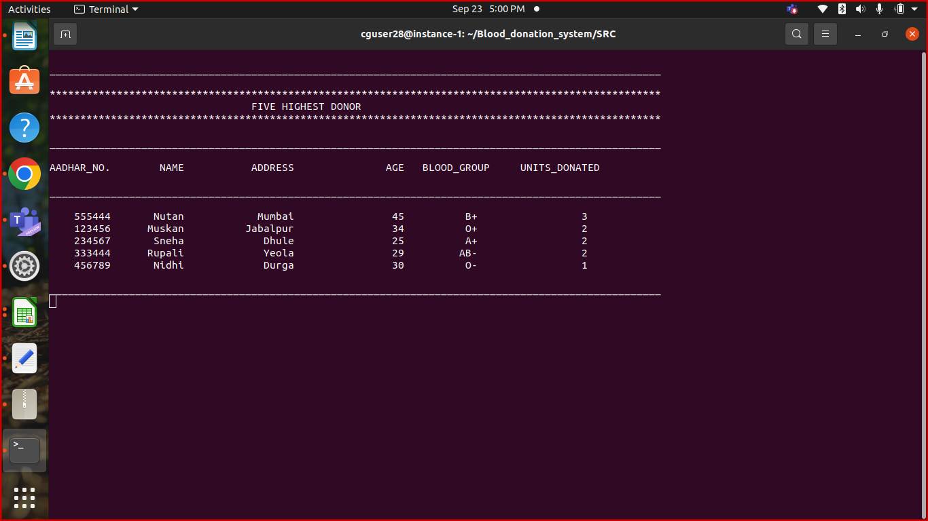

**IT_CASE 14 : EMPTY_TRANSACTION_FILE**

